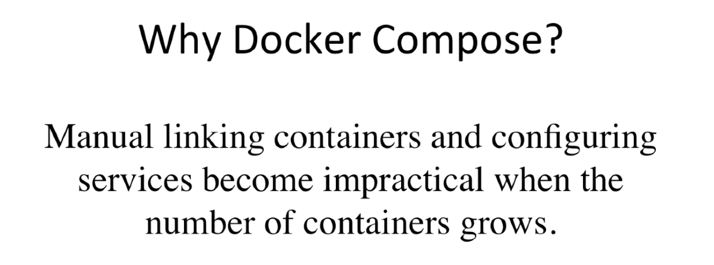



Kiểm tra xem docker compose đã install chưa

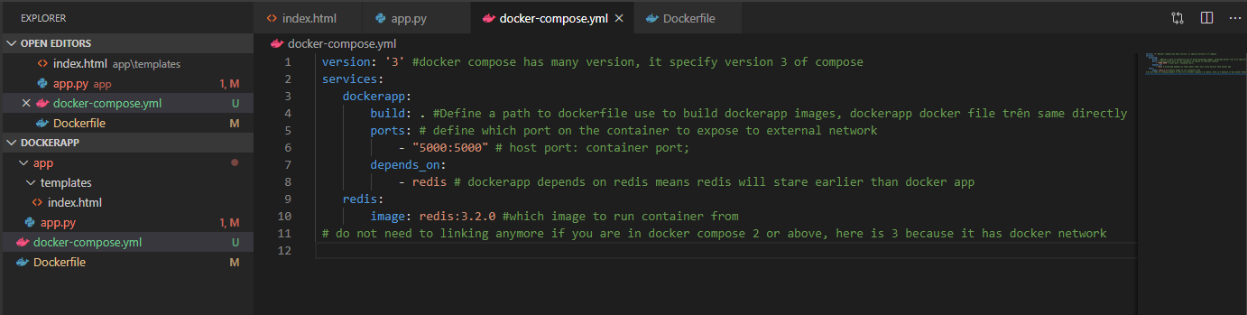



Stop all the running container to avoid conflic



